Enhancing Precision in Custard Apple Disease Identification Using Deep Learning
Abstract. Diseases that affect the health of the plant and reduce productivity frequently compromise custard apple cultivation. Effective management strategies require early and accurate detection of diseases. The present study is a novel approach to the identification of custard apple leaf diseases using a Convolutional Neural Network (CNN) model trained on a dataset of 8680 images. Images are optimized to enable feature extraction using advanced preprocessing techniques, by which the model classifies diseases accurately to 91.01%. It has also been classified over seven categories including Anthracanose disease, Blank Canker, Diplodia Rot, Healthy leaf, Leaf spot on fruit, Leaf spot on leaves, and MealyBug. Deployment of the model via a web application using the Django-based environment sets this project apart and gives it a reality to practical applications. Thorough experimentation and testing, coupled with evaluation, enable the system to show promising results, making this a scalable approach for precision agriculture and providing the basis for subsequent applications in detecting diseases across various crops.
Keywords: CNN, Custard Apple Leaf Diseases, Deep Learning, Django Deployment, Image Processing.
- Introduction
Custard apple (Annona squamosa), a valuable tropical fruit crop, plays a significant role in the agricultural economy. However, its cultivation is often threatened by a variety of diseases that affect plant health, reduce yield, and disrupt overall productivity. Early identification and management of these diseases are crucial to mitigate their impact and ensure sustainable cultivation practices. Traditional methods of disease detection are labor-intensive, time-consuming, and prone to inaccuracies, making them less effective for large-scale monitoring.
  - Outline of Research
Custard apple seeds have therapeutic qualities and exhibit potent anticancer efficacy against a variety of tumours; for this study, we used the Annona squamosa Dataset. Considering the medicinal uses and the increasing utilization of Annona squamosa, we were prompted to work on this data. The primary reason for proposing a CNN for this project is its simplicity, computational efficiency, and suitability for the dataset size. CNNs strike a balance between performance and complexity, making them ideal for tasks such as custard apple disease detection. They require fewer computational resources, train faster, and are easier to interpret compared to more advanced architectures like ResNet or EfficientNet. As we move forward with the research, this proactive approach can help mitigate crop losses, optimize resource allocation and enhance crop health and productivity.
To summarize the paper the upcoming section covers the literature review regarding the knowledge of Annona squamosa and its medicinal usage, with some botanical advantages. Further the Methodology section covers all the information regarding the tools and systems used and model developed for the research. Finally, the Results and discussion covers all the achievable information collected during the process.
  - Objective of Research
The research has been done keeping some major objectives in focus:
- Development of robust system for detecting diseases in Annona squamosa using CNN, due to its computational efficiency and simplicity.
- Implement image processing techniques to accurately classify diseases among various categories.
- Investigating the feasibility and effectiveness of CNN-based deep learning models in achieving high accuracy (91.01%) for disease detection.
- Deploying the system through a Django-based web application to assure practical usability for agricultural stakeholders
- Explore the avenues for future research and development to enhance the capabilities and performance of the proposed model for actual application in agricultural industry and plant pathology research.
- Literature Survey
Jianwei Chen et.al study [1] states that custard apple seeds have medicinal properties, showing strong antitumor activity against various cancers. However, they can cause adverse effects like blindness and reduced movement. Naser et.al, study [2] focuses on developing an expert knowledge-based system to diagnose custard apple diseases accurately, enabling farmers to identify issues and provide appropriate treatments effectively, thereby minimizing crop damage. Khandekar et.al, [3] this paper analyses leaf parameters for plant growth assessment and uses image processing and machine learning techniques to detect custard apple leaf diseases, emphasizing the need for tailored algorithms. Hangarge et.al, study [4] uses deep learning models AlexNet and SqueezeNet to automatically identify and diagnose fungal diseases in Custard apple leaves, a major concern due to yield losses in agriculture. Bari et.al,[5] proposes a Vision-based detection of mealybug infection in custard apples uses machine learning algorithms to identify infestations from images. This enhances monitoring and reduces pesticide use. Dharanesh S et.al, [6] this study uses convolutional neural networks (CNNs) to classify custard apple leaf diseases, achieving 85% accuracy. Early disease detection aids in controlling infections and promoting healthy plant growth. Khandekar et.al, [7] this study uses k-NN and SVM algorithms to detect nutrient deficiencies and diseases in custard apple leaves, achieving 99.5% accuracy with image processing techniques. The research by Renugadevi et al. [8] used CNNs to classify custard apple leaves, focusing on disease detection. Reddya et.al, [9] this study presents a low-cost prototype device using image processing and machine learning for detecting maturity stages of custard apple (Annona squamosa) fruits. The device, built with Raspberry Pi, a camera module, and Python-based algorithms, classifies five maturity stages with 100% accuracy, aiding farmers and industries in accurate grading, reducing economic losses, and improving fruit marketing and storage. Khandekar et.al, [10] This paper proposes a system for analysing custard apple leaf parameters, detecting nutrient deficiencies (N, P, K), and identifying leaf diseases using image processing and machine learning techniques. Classification using k-NN and SVM achieved 99.5% accuracy, demonstrating the effectiveness of the supervised approach for sustainable agriculture. Brohi et.al, [11] this study compares machine learning (SVM, RF, SGD) and deep learning (Inception-v3, VGG-16, VGG-19) methods for citrus plant disease detection. Experimental results show that deep learning models outperform machine learning techniques, with VGG-16 achieving the highest classification accuracy of 89.5%. Mathew et.al, [12] the study presents a deep learning-based approach for tomato plant leaf disease detection and classification using a hybrid optimization technique. The model combines U-net with Gradient-Golden Search Optimization for segmentation and DbneAlexnet with Gradient Jaya-Golden Search Optimization for classification, achieving 92.4% accuracy, 91.9% TPR, and 92.2% TNR. Patil et.al, [13] the study introduces a lightweight deep learning model, Lite-MDC, for real-time pigeon pea disease detection, leveraging a novel dataset from 18 Indian states. The model achieves 94.14% accuracy with a 62% parameter reduction compared to VGG16, enabling efficient deployment on resource-constrained devices like agricultural robots and drones. Kurulay et.al, [14] the study introduces a deep learning approach using a compact Inception model to detect diseased leaf regions, achieving 94.04% accuracy on Plant Village and 97.13% on unseen datasets, offering a scalable solution for robust, cross-crop disease detection. Using deep convolutional neural networks (CNNs) trained on leaf pictures, Stefanovic et al. [15] describe a unique method to enhance plant disease recognition. With an average precision of 96.3%, the model can identify 13 plant illnesses. It uses the Caffe framework for effective implementation and real-world application in agriculture. A CNN-based approach with image augmentation is proposed by Bouallegue et al, [16] to enhance wheat leaf disease detection, and it achieves 94% accuracy for resource-efficient, real-time disease diagnosis. Kang et.al, [17] This study introduces the Apple Leaf and Fruit Disease Prediction (ALFDP) architecture for early disease detection in Kashmiri apples. A hybrid CNN-LSTM model achieved superior accuracy of 99%, demonstrating its effectiveness for real-time disease monitoring in apple orchards. Mehende et.al, [18] this study presents a DenseNet-161-based plant classification model capable of identifying 79 species with 97.3% accuracy, optimized for offline use on Android devices. The application aids farmers by providing species details through quick image-based classification with an average latency of 1.98 seconds. MT et.al, [19] the study develops a web-based plant disease detection and treatment recommendation system using a CNN model integrated with the Django framework. The system effectively classifies diseases and provides preventive measures, aiming to assist farmers and educate communities. Kishore et.al, [20] the study presents an automated plant disease detection system using image processing and a Django-based web platform. By analysing uploaded leaf images, the system identifies diseases with high accuracy, aiding farmers in early detection and reducing effort in monitoring large farms.
The proposed model aims to provide an automated, accurate, and scalable solution for early detection of custard apple leaf diseases using Convolutional Neural Networks (CNNs). By leveraging a dataset of 8680 images, the model achieves 91.01% accuracy in classifying seven distinct disease categories. The integration of advanced image preprocessing techniques enhances feature extraction and improves classification performance. Furthermore, the model is deployed through a Django-based web application, ensuring accessibility and practicality for farmers and agricultural practitioners. This approach offers a foundation for precision agriculture, enabling efficient disease management and contributing to improved productivity in custard apple cultivation.
- Proposed Methodology
  - Data Preparation
Further, to proceed with, [8] the dataset used is Custard Apple (Annona squamosa) Dataset, contains 8680 images belonging to 7 classes that are:

Category | Number of Images
Anthracanose | 1075
Black Canker | 1780
Diplodia Rot | 1645
Healthy | 454
Leaf Spot on Fruit | 867
Leaf Spot on Leaf | 1255
Mealy Bug | 1604
Table 1. Image Dataset
The dataset used in this research underwent meticulous preprocessing to ensure uniformity and compatibility for model training. Specifically, the following steps were performed as part of the data preparation process:

Resizing and Rescaling Images
The images underwent preprocessing, specifically resizing, to ensure uniformity. Employing the ‘keras.layers’ module from preprocessing layers, the images were resized to the dimensions 128x128 pixels and resized to scaling equals to (1.0/127). This resizing and rescaling step not only standardized the image sizes but also facilitated subsequent processing steps, streamlining the computational workload

Batch Processing
The dataset was organized into batches to facilitate efficient loading and processing during model training. Each batch contained 64 images, ensuring a balance between computational resources and batch size.

Label Encoding
The labels that go with every image were encoded into binary format using NumPy arrays. A value of 1 meant there was a particular attribute or condition present, while a value of 0 indicated its absence.

Dataset Splitting
The dataset was partitioned into three clear subsets to be used for validation, testing and training purposes. This verifies that the model would be trained on a variety of set of data while being calculated on not seen instances to evaluate performance correctly regarding generalization.

Data Visualization
For imagining the data present in the dataset, using the library Matplotlib creates a grid of 12 images with their respective labels. Each of the image is displayed with its corresponding label which provides a view of the data preprocessing and organization.
  - Model Workflow
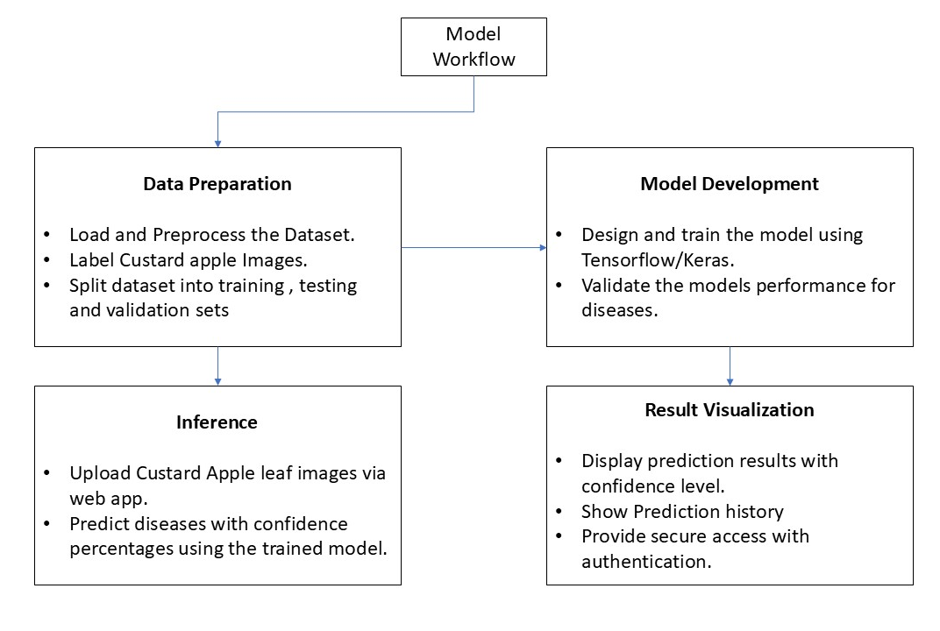
Fig. 1. Model Workflow
  - Architecture of proposed model

CNN Model
The Convolutional Neural Network (CNN) architecture proposed, comprises of multiple convolutional layers such as Conv2D, MaxPooling2D, Flatten and Dense coupled with loss function “Relu” to preserve the spatial information and manage the losses the weights across the layers. These special features are bestowed from the “keras.layers” provided by the Keras module. Initially, the Conv2D layer (2D Convolution Layer) is used to produce a tensor of outputs by convoluting the input layer over a single spatial dimension, that is layering with the 128x128 pixels image layer. This layer fabricates a convolution kernel that further will connect with other convolutional layers. The class of Conv2D layer provides various different feature for exercising different biases and features on the image through the layer. As for the research, we have used the ‘filters’, ‘kernel_size’, ‘activation’ and ‘input_shape’ functions for the initial layer. And for the upcoming layers of Conv2D only ‘filters’, ‘kernel_size’ and ‘activation’ functions are used.
The MaxPooling2D layer (2D MaxPooling) adopts the maximum value of each channel in the input over an input window and down measures the input along its dimensional parameters (height and width). Then the window is shifted strides by strides along the image’s dimensions. The parameter passed for this layer is ‘pool_size’ to determine the size of the striding window.
After few layers of Conv2D and MaxPooling2D the Neurals have been shape down to few Neurals which are finally flatten and dense down to classify the images more accurately. To perform these functional layers the “keras.layers” module provide ‘Flatten’ and ‘dense’ functions to transform the image to very minimal.
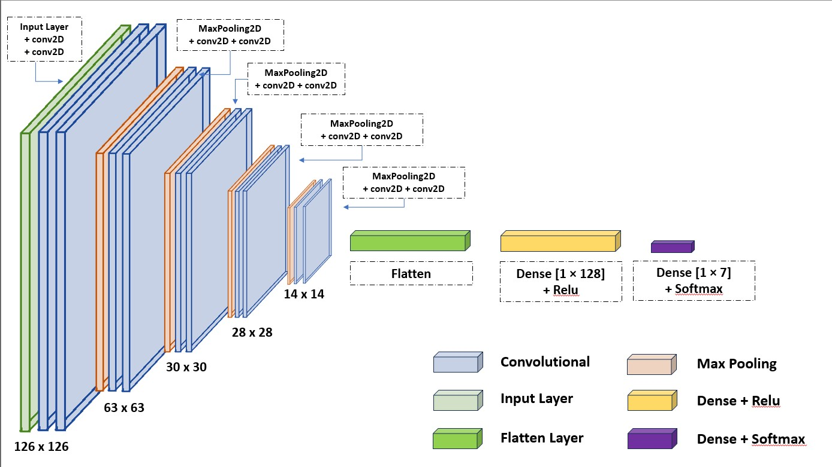
Fig. 2. Breakdown of CNN Model
  - Mathematical Model
While developing the CNN model the mathematical calculations that has been in learned and used is as followed:

Convolution Layer
The Convolutional Operation for an input layer I of shape H (Height) x W (Width) x C (Channel) and a kernel K of size k_{h} x k_{w} x C, the convolution operation produces an output tensor O:
$$O_{i,j}=\sum_{c=1}^{C}{ }\sum_{m=1}^{kh}{ }\sum_{n=1}^{kw}{I_{i+m-1,j+n-1,c} ×K_{m,n,c}} ( SEQ "equation" \backslash n \backslash * MERGEFORMAT 1)$$

Output shape for the same can be calculated using
$${ H}_{out}=\left[\frac{H+2p-k_{h}}{s}\right]+1 ( SEQ "equation" \backslash n \backslash * MERGEFORMAT 2)$$

$${ W}_{out}=\left[\frac{W+2p-k_{w}}{s}\right]+1 \left( SEQ "equation" \backslash n \backslash * MERGEFORMAT 3\right)$$
where the s defines stride size with the H x W x C as input size and k_{h} x k_{w} as kernel size.

Max Pooling Layer
This layer is for reducing the spatial dimensions of the input. For a pool size p_{h} x p_{w} and the stride s:
$$H_{out}=\left[\frac{H-p_{h}}{s}\right]+1 ( SEQ "equation" \backslash n \backslash * MERGEFORMAT 4)$$

$$W_{out}=\left[\frac{W-p_{w}}{s}\right]+1 ( SEQ "equation" \backslash n \backslash * MERGEFORMAT 5)$$

Parameters
The number of parameters in a convolutional layer is:
$$params=\left(k_{h}×k_{w}×C+1\right)×C_{out} \left( SEQ "equation" \backslash n \backslash * MERGEFORMAT 6\right)$$
These essential mathematical formulations are for the understanding of the model’s convolutional, pooling and dense layers.
  - Evaluation of Models
The Accuracy, Precision, Recall and F1-score are calculated on the basis of the given mathematical expressions:

Accuracy
$$\frac{Tp+Tn}{Tp+Tn+Fp+Fn} \left( SEQ "equation" \backslash n \backslash * MERGEFORMAT 7\right)$$

Precision
$$\frac{Tp}{Tp+Fp} ( SEQ "equation" \backslash n \backslash * MERGEFORMAT 8)$$

Recall
$$\frac{Tp}{Tp+Fn} ( SEQ "equation" \backslash n \backslash * MERGEFORMAT 9)$$

F1 Score
$$\frac{2×precision×recall}{precision+recall} \left( SEQ "equation" \backslash n \backslash * MERGEFORMAT 10\right)$$

Where

TP: True Positive
TN: True Negative
FP: False Positive
FN: False Negative

These metrics provide a comprehensive idea of the model’s performance. By analyzing these metrics, we got some effective insights of our classification model.
- Results and Discussion
  - Model Performance
The performance of the CNN model was evaluated using metrics such as accuracy, precision, recall, and F1-score. The model achieved an overall classification accuracy of 91.01% on the test dataset. Each disease category was analyzed individually to ensure balanced performance, with precision and recall values exceeding 90% for most classes.
  - Classification Report
The classification report provided detailed insights into the model’s ability to distinguish between the seven disease categories. The following metrics summarize the model’s performance:

 | Precision | Recall | F1 Score | Support
Anthracanose | 0.89 | 0.80 | 0.85 | 204
Black Canker | 0.88 | 0.89 | 0.89 | 324
Diplodia Rot | 0.92 | 0.97 | 0.94 | 333
Healthy | 1.00 | 0.94 | 0.97 | 88
Leaf Spot on fruit | 0.86 | 0.86 | 0.86 | 176
Leaf Spot on leaves | 0.91 | 0.97 | 0.94 | 267
Mealy Bug | 0.95 | 0.90 | 0.92 | 344
Accuracy |  |  | 0.91 | 173
Macro Avg | 0.92 | 0.91 | 0.91 | 1736
Weighted Avg | 0.91 | 0.91 | 0.91 | 1736
Table 2. Classification Report

A confusion matrix was generated to visualize the model’s predictions against labels.
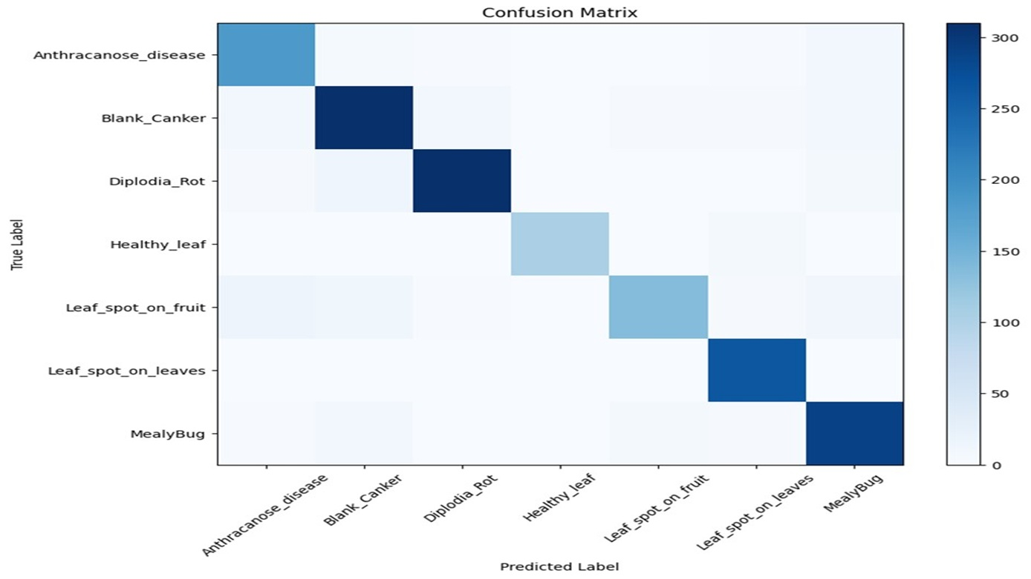
Fig. 3. Confusion Matrix of Proposed Model
  - Results of Proposed Model
The CNN model proposed for the research gave quite the satisfactory results. The visualization of the CNN model:
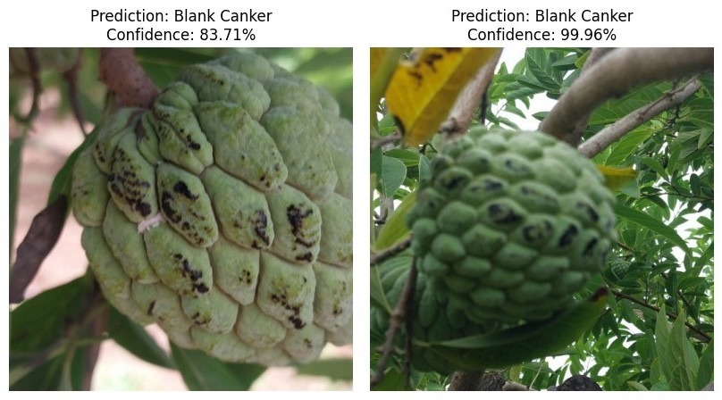
Fig. 4. Result output of Proposed Model
Fig 4. shows, the predicted and actual results with confidence level above 80%.
  - Training and Validation Matrix
The training process was monitored to track loss and accuracy over epochs. The training loss decreased steadily, starting at 1.35 and reaching 0.10 by the final epoch. Validation accuracy mirrored the training performance, stabilizing at 91% after 40 epochs. These trends confirm that the model is neither overfitting nor underfitting.
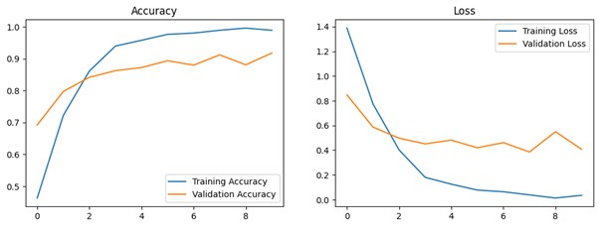
Fig. 5. Accuracy and Loss Graph of Proposed Model
  - Web Application Result
The deployed web interface enabled users to upload images for disease detection. The system provided predictions with confidence levels above 90% for most inputs. For instance:
- Input Image: Leaf with signs of Diplodia Rot
- Prediction: Diplodia Rot with 99.93% confidence
Users found the interface intuitive and effective for real-time disease identification. Additional features, such as prediction history and disease prevention tips, enhanced user engagement.
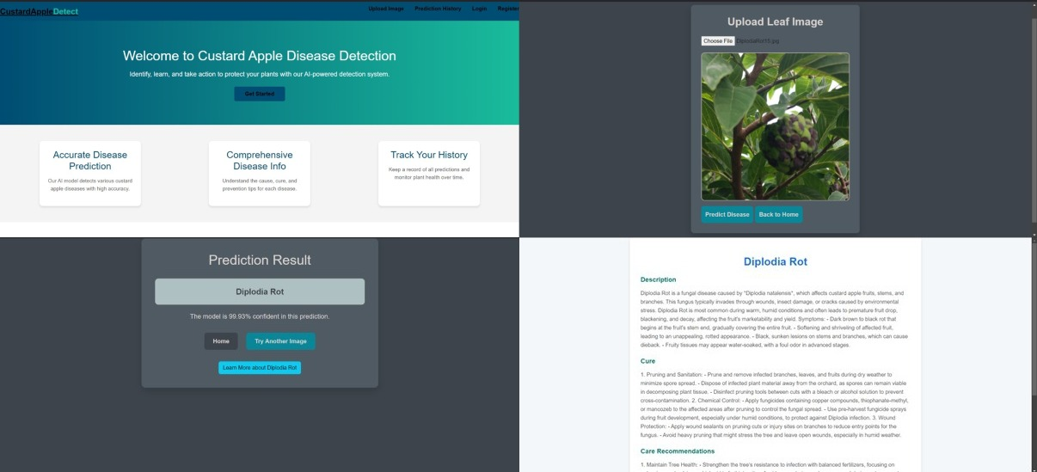
Fig. 6. Web Application features and Their Outcomes
The proposed system demonstrates the potential of deep learning models in precision agriculture. Its ability to accurately classify multiple diseases highlights its robustness and scalability. While the model achieved impressive results, future work could explore:
- Expanding the dataset to include additional disease categories.
- Optimizing the model for deployment on mobile and edge devices.
- Integrating multi-language support for broader accessibility.
The combination of a high-performing CNN model and a user-friendly web application sets a strong foundation for addressing agricultural challenges using AI-driven solutions.
- Conclusion
This study demonstrates the efficacy of a Convolutional Neural Network (CNN) combined with image segmentation techniques in the early and precise detection of diseases in custard apple plant leaves. Utilizing a dataset of 8680 images, the model achieved a classification accuracy of approximately 91.01%, underscoring its potential as a valuable tool in the realm of precision agriculture. The high accuracy rate not only enhances disease management strategies but also paves the way for sustainable cultivation practices. Given the success with custard apple plants, this approach holds promise for adaptation and implementation in other crop species, potentially revolutionizing agricultural disease management through technology.

References
- Jianwei Chen, Yong Chen, Xiang Li, “Beneficial Aspects of Custard Apple (Annona squamosa L.) Seeds”, Nuts and Seeds in Health and Disease Prevention, 2011, pp.439-445.
- [2] Mustafa M. K. Al-Ghoul, Mohammed H. S. Abueleiwa, Fadi E. S. Harara, Sami M. Okasha, Samy S. Abu-Naser, “Knowledge Based System for Diagnosing Custard Apple Diseases and Treatment”, International Journal of Academic Engineering Research (IJAER) ISSN: 2643-9085 Vol. 6 Issue 5, May - 2022, Pages: 41-45.Author, F., Author, S., Author, T.: Book title. 2nd edn. Publisher, Location (1999).
- Appasaheb Gargade, S.A. Khandekar, “A Review: Custard Apple Leaf Parameter Analysis and Leaf Disease Detection using Digital Image Processing”, 2019 3rd International Conference on Computing Methodologies and Communication (ICCMC), 27-29 March 2019.
- Sukanya S. Gaikwad, Shivanand S Rumma, Mallikarjun Hangarge, “Classification of Fungi Infected Annona Squamosa Plant Using CNN Architectures”, Proceedings of the 13th International Conference on Soft Computing and Pattern Recognition (SoCPaR), 2021, pp.170-177.
- Swati Shilaskar, Pratham Bannore, Tejas Badhe, Nayan Bari, “Vision Based Detection of Mealybug Infection in Custard Apple Using Machine Learning”, 2023 International Conference in Advances in Power, Signal, and Information Technology (APSIT), 9-11 June 2023.
- Renugadevi A.S, Ananthi B, Dr.Jayavadivel R , Pradeep S , AravindM, ,Dharanesh S, “Classification of Custard Apple Leaves Using Deep Convolutional Networks”, Turkish Journal of Computer and Mathematics Education, Vol.12 No.6, 2021, pp.3288-3292.
- Appasaheb Gargade, Shridhar Khandekar, “Custard Apple Leaf Parameter Analysis, Leaf Diseases, and Nutritional Deficiencies Detection Using Machine Learning”, Advances in Signal and Data Processing, January 2021, pp.57-74.
- Sandip Thite, Kailas Patil, Rohini Jadhav, Yogesh Suryawanshi, Prawit Chumchu , “Empowering agricultural research: A comprehensive custard apple ( Annona squamosa ) disease dataset for precise detection”, Data in Brief journal, 2024, database link: https://data.mendeley.com/datasets/jtgh2885yf/2.
- G.C. Wakchaurea, Sonal B. Nikamb, Kiran R. Bargec, Satish Kumard, Kamlesh K. Meenae, Vinay J. Nagalkarb, J.D. Choudharia, V.P. Kadc, K.Sammi Reddya, “Maturity stages detection prototype device for classifying custard apple (Annona squamosa L) fruit using image processing approach”, SmartAgriculturalTechnology 7, 2024.
- Appasaheb Gargade, Shridhar Khandekar, “Custard Apple Leaf Parameter Analysis, Leaf Diseases, and Nutritional Deficiencies Detection Using Machine Learning”, Lecture Notes in Electrical Engineering (LNEE),Volume 703, 12 January 2021, pp 57–74.
- R. Sujatha, Jyotir Moy Chatterjee, NZ Jhanjhi, Sarfraz Nawaz Brohi, “Performance of deep learning vs machine learning in plant leaf disease detection”, Microprocessors and Microsystems, Volume 80, February 2021.
- Manjunatha Badiger, Jose Alex Mathew, “Tomato plant leaf disease segmentation and multiclass disease detection using hybrid optimization enabled deep learning”, Journal of Biotechnology, Volume 374, 10 September 2023, pp.101-113.
- Sandesh Bhagat, Manesh Kokare, Vineet Haswani, Praful Hambarde, Trupti Taori, P.H. Ghante, D.K. Patil, “Advancing real-time plant disease detection: A lightweight deep learning approach and novel dataset for pigeon pea crop”, Smart Agricultural Technology, Volume 7, March 2024.
- Imane Bouacida, Brahim Farou, Lynda Djakhdjakha, Hamid Seridi, Muhammet Kurulay, “Innovative deep learning approach for cross-crop plant disease detection: A generalized method for identifying unhealthy leaves”, Information Processing in Agriculture, 2 March 2024.
- Srdjan Sladojevic, Marko Arsenovic, Andras Anderla, Dubravko Culibrk, Darko Stefanovic, “Deep Neural Networks Based Recognition of Plant Diseases by Leaf Image Classification”, Computational Intelligence and Neuroscience, 22 June 2016 https://doi.org/10.1155/2016/3289801.
- Oumayma Jouini, Kaouthar Sethom, Ridha Bouallegue, “Wheat leaf disease detection using CNN in Smart Agriculture”, 2023 International Wireless Communications and Mobile Computing (IWCMC), 19-23 June 2023.
- Maroof Ul Mushtaq, Sanjay Singla, Sandeep Singh Kang, “Deep Learning based model for early detection of disease in Apple Leap and Fruit”, 2024 First International Conference on Technological Innovations and Advance Computing (TIACOMP), 29-30 June 2024.
- Ankita Shelke, Ninad Mehendale, “A CNN-based android application for plant leaf classification at remote locations”, Neural Computing and Applications, 02 September 2022, Volume 35, pp.2601–2607,
- Raihan Haidar Arkan and Dr. Nur Sultan Salahuddin, SKom, MT, “Leaf Disease Detection Web Design using Django Framework for CNN Models,” International Research Journal of Advanced Engineering and Science, Volume 8, Issue 4, 2023, pp. 5-11.
- Jyothirmai Sai Sri Gelli, Lakshmi Akhila Madduri, Roshan Tanveer, Udaya Bhanu, G Krishna Kishore, “Plant Disease Detection Using VGG and Django”, International Research Journal of Engineering and Technology (IRJET), Volume: 07 Issue: 08, Aug 2020.

